**Experiment No.: 10**

**Bluetooth protocol stack**



1. **Aim: Study on Bluetooth protocol stack**
2. **Objectives:** To introduce concepts and fundamentals of data communication and computer networks.
3. **Outcomes:** The learner will be able to

* Analyze the functioning of Bluetooth for communication.

1. **Hardware/Software required:** Device with Bluetooth feature
2. **Theory:**

Bluetooth wireless technology is a short-range radio technology, which is developed for Personal Area Network (PAN). Bluetooth is a standard developed by a group of electronics manufacturers that allows any sort of electronic equipment -- from computers and cell phones to keyboards and headphones -- to make its own connections, without wires, cables or any direct action from a user.

Bluetooth wireless technology makes it possible to transmit signals over short distances between telephones, computers and other devices and thereby simplify communication and synchronization between devices.

It is a global standard that:

• Eliminates wires and cables between both stationary and mobile devices

• Facilitates both data and voice communication

• Offers the possibility of ad hoc networks and delivers the ultimate synchronicity between all your personal devices

Bluetooth is intended to be a standard that works at two levels:

• It provides agreement at the physical level -- Bluetooth is a radio-frequency standard.

• It also provides agreement at the next level up, where products have to agree on when bits are sent, how many will be sent at a time and how the parties in a conversation can be sure that the message received is the same as the message sent.

Bluetooth Architecture

There are two types of topology for Bluetooth – Piconet, Scatternet.

1. Piconet :- The Piconet is a small ad hoc network of devices (normally 8 stations).

It has the following features:

* One is called Master and the others are called Slaves
* All slave stations synchronizes their clocks with the master
* Possible communication - One-to-one or one-to-many

1. Scatternet :- It is formed by combining several Piconets.

Key features of the scatternet topology are mentioned below:

• A Scatternet is the linking of multiple co-located piconets through the sharing of common master or slave devices.

• A device can be both a master and a slave.

Bluetooth Protocol Stack and Architecture

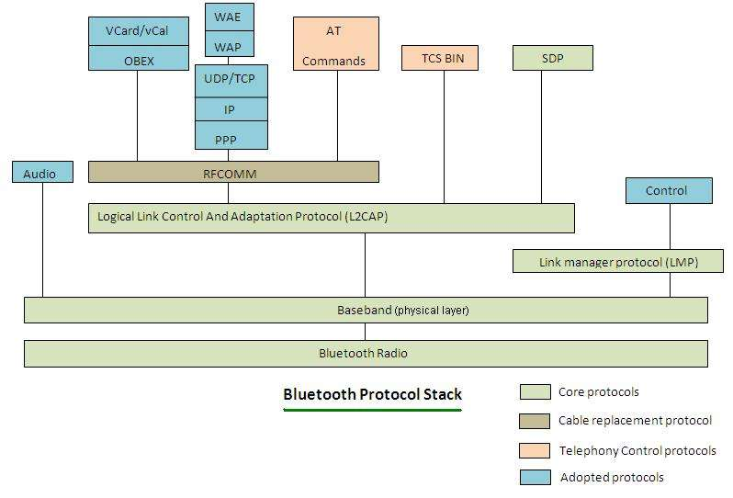

The different layers of Bluetooth Architecture are –

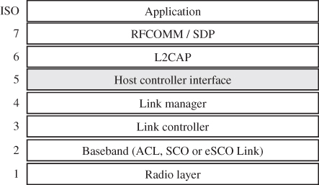

• Radio Layer: The Radio layer defines the requirements for a Bluetooth transceiver operating in the 2.4 GHz ISM band.

• Baseband: The Baseband layer describes the specification of the Bluetooth Link Controller (LC), which carries out the baseband protocols and other low-level link routines. It specifies Piconet/Channel definition, “Low-level” packet definition, Channel sharing.

• LMP: The Link Manager Protocol (LMP) is used by the Link Managers (on either side) for link set-up and control.

• HCI: The Host Controller Interface (HCI) provides a command interface to the Baseband Link Controller and Link Manager, and access to hardware status and control registers.

• L2CAP: Logical Link Control and Adaptation Protocol (L2CAP) supports higher level protocol multiplexing, packet segmentation and reassembly, and the conveying of quality of service information.

• RFCOMM: The RFCOMM protocol provides emulation of serial ports over the L2CAP protocol. The protocol is based on the ETSI standard TS 07.10.

• SDP: The Service Discovery Protocol (SDP) provides a means for applications to discover, which services are provided by or available through a Bluetooth device.

• Application : These are software modules which connect the host application program to the Bluetooth communications system. As such they reside and execute on the same processing resource as the host system application.

1. **Conclusion** :

Thus we have studied the different layers in Bluetooth protocol stack.

1. **Output Analysis:**

(Students should write output analysis based on the working of different topology and different networking devices used in simulation. Specify each scenario explicitly with output analysis)

1. **Additional Learning:**

(Students should write additional learning on their own based on what additionally they learnt after performing the experiment)

1. **Conclusion :**

(Students should write conclusion on their own)

1. **Viva Questions:**

* State advantages and disadvantages of each of bluetooth
* Name different layers of Bluetooth protocol stack.
* What is piconet and scatternet.

1. **References:**
   1. A.S. Tanenbaum, “Computer Networks”, Pearson Education, (4e).
2. B.A. Forouzan, “Data Communications and Networking”, TMH (5e).
3. James F. Kurose & K W Ross: Computer Networking: A Top Down Approach, Pearson Education (LPE)